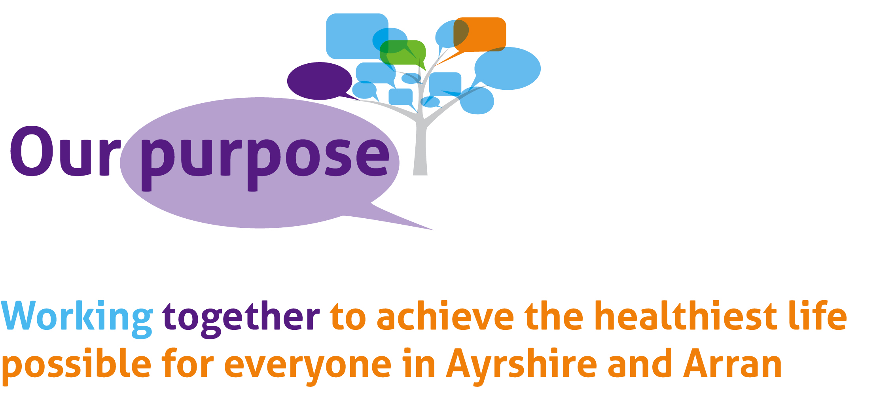

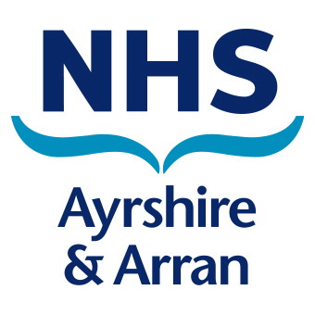

**Statement of Commitment to Gender Equality**

As part of our commitment to gender equality, NHS Ayrshire & Arran is pleased to announce that we are participating in the Equally Safe at Work accreditation programme. NHS Ayrshire & Arran is committed to progressing gender equality in the workplace and this programme provides the tools to take this forward to address inequality in the labour market, reduce violence against women and measure equalities through a gender lens.

NHS Ayrshire & Arran aims to ensure that all female employees feel safe at work as they are valuable members of the workforce, making up 84% of our workforce. Participation in the programme provides the opportunity to demonstrate leadership both in the workplace and within the wider community by showing that steps are being taken to address gender inequality and prevent violence against women.

We also recognise that there is an integral link between addressing gender inequality and preventing violence against women and that starts with addressing women’s workplace inequality. Over the coming months we will be undertaking a number of activities to progress the Equally Safe at Work programme. This will include looking at recruitment and career progression practice, holding awareness-raising sessions and promoting our work on violence against women. This will enable us to ensure best practice, and reflect the needs of NHS Ayrshire & Arran’s employees.

Gender equality benefits everyone and it’s important that all employees in the workplace feel safe and supported. Equally Safe at Work will allow NHS Ayrshire & Arran to further ensure that our core values of caring, safe and respectful underpin everything we do and are integral to our overall purpose of ‘**Working together to achieve the healthiest life possible for everyone in Ayrshire and Arran’**.

We will ensure that the changes we make are sustainable and will work to embed these throughout the organisation. We will consistently review the changes we implement to ensure that they still reflect the needs of the Board and our employees.

~~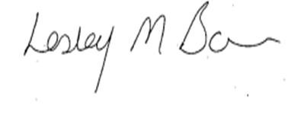~~ 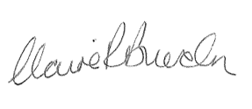

____________________________ ____________________________

**Lesley Bowie Claire Burden**

**Chair of NHS Ayrshire & Arran Board Chief Executive**