Application to Volunteer with  NHS Ayrshire & Arran |  | 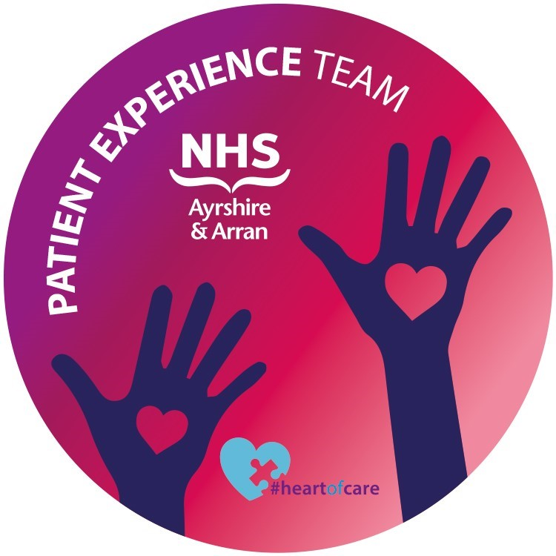
Staff use only (mandatory VIS dates)
Enquiry date | __/___/____
Application received date | __/___/____
Interview date | __/___/____
Process completed date | __/___/____
Placement date | __/___/____

Volunteer role title you would like to apply for:

To ensure our volunteering opportunities are open to all, NHS Ayrshire and Arran operates an equal opportunities policy and complies with all equalities legislation to ensure everyone is treated fairly and appropriately.

Title |  | First name |  | Surname
Address (including postcode)

Land telephone number |  |  |  |  | Mobile telephone number
Email address |  |  |  |  | Date of Birth (dd/mm/yyyy)
Preferred method of contact – tick box(es) that apply
Post | Land tel |  | Mob tel |  |  | Email

How did you hear about volunteering in NHS Ayrshire & Arran? Please tick only one
Another NHS Board |  | DWP
Higher/Further education |  | Local media
Member of staff |  | NHS Board website
Volunteer centre |  | Word of mouth
Other, please specify:

Please let us know why you are interested in this particular volunteering role:

Have you had any experience of working in a healthcare setting?
If yes, please provide some details:

Have you ever undertaken any voluntary work before?
If yes, please provide some details:

What particular experience or skills do you think you could bring to this volunteering role?

Referees: Please give the names and contact details of two people who have known you in a community or professional capacity for at least two years and are prepared to provide a reference for you.

Person 1
Title | First name |  | Surname
Address (including postcode)

Telephone number |  | Email address

Person 2
Title | First name |  | Surname
Address (including postcode)

Telephone number |  | Email address

Signed…………………………………………. Date………………………

Please complete and return this form to the recruiting staff member via email: volunteering@aapct.scot.nhs.uk or print and post to:

Karen Parker, Volunteer Manager, NHS Ayrshire & Arran, Eglington House, Ailsa Hospital, Dalmellington Road, Ayr KA6 6AB

Fair Processing notice
You are providing your personal details to NHS Ayrshire & Arran as part of your role as a volunteer within the health board. The information you provide is necessary to enable the board to manage and deliver high quality volunteering opportunities and placements as part of its public function.
Your information is added to a database, the Volunteering Information System, and is used to match volunteers with appropriate opportunities and to retain a record of volunteering activity for administration purposes. Anonymised reports will be created from the information and used to inform service developments at a local and national level.
The Volunteering Information System is administered by Healthcare Improvement Scotland, hosted in the National Waiting Times Centre and supported by a partner agency appointed on an annual basis. These agencies are data processors and must adhere to strict access controls. Your personal details will not be shared within the organisations or with other external organisations unless otherwise agreed or if the law says we should.
The details you provide will be stored in an online secure database within the NHS network accessible to only the volunteering management team and kept for six years from the point you cease volunteering.
You have the right to ask us for a copy of your information, or to delete or correct it if you think it is inaccurate. You can ask for data you have given us to be sent to you in electronic format, if processed by automatic means and on the basis of consent or contract. At any time you can ask us to stop or limit the processing of your personal data.
NHS Ayrshire & Arran employ a Data Protection Officer to check that we handle personal information in a way that meets data protection law. If you have any questions or are unhappy with the way in which we use your personal information please tell the Data Protection Officer using the contact details below.
You can find out more about how we process your personal information in our full privacy notice available online at: www.nhsaaa.net . Our Data Protection Officer’s contact details are: Jillian Neilson, Head of Information Governance & DPO, 14 Lister Street, Crosshouse Hospital; Tel: 01563 826813 or 01563 825897 or Email: InformationGovernance@aapct.scot.nhs.uk You also have the right to complain about how your personal information is used to the Information Commissioner’s Office (ICO). Details about this are on their website at www.ico.org.uk.

